🎨 Theme Switcher

Step 1: Layout
** Follow layout of HyprGruv settings; this is mainly for how the buttons are laid out and options underneath
Layout for the color palette should follow look-and-feel styling icons to the settings Rofi
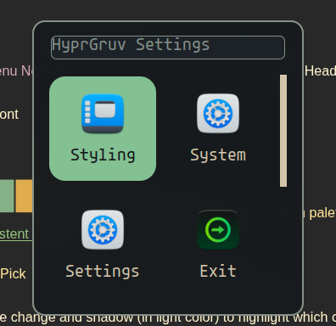

**Use this ‘styling’for font transition, blur, format **** except that this will be in one line like the color palettes from below

Needs to be more of a scrolling horizontally type rofi; example layout is in
~/Documents/Hypercourse/meridian/.config/rofi

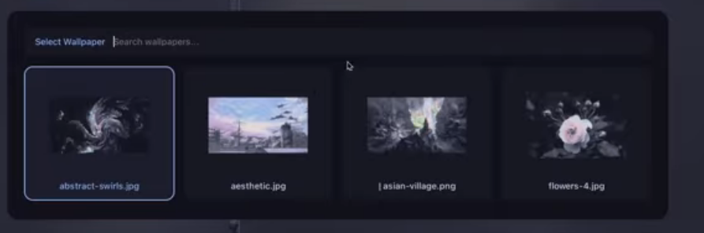

Do not need to put the color names because it is not consistent across palettes (ie some have 2 greens and not a red, blue, green, cyan)

Along these lines, for just the way the buttons look with ‘Default ’ and ‘HyprPicker ’, and …
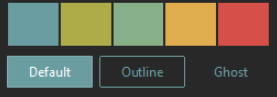
^Default Hyprpicker Back

Top Drop Down:
**No Dropdown Menu Needed (theme already chosen) > Just Needs Header with ‘Select Primary Color’
Using System font

Middle Panel:

One panel with the colors from palettes (scroll left to right through palette; highlight the selected with the new theme's primary source color/ the rest of the theme is standard, choices, if the source color chosen via the rofi palette is used in the theme for other color values then swap with the standard/default’ source color)
Bottom panel persistent with:
⭐ Default 🖌️ Pick 🔙 Back = 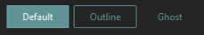

Step 2: Fix Awkward Active Window Border, bring image
In the current version, the picture previews have an unfilled border between the ‘active selection’ border and the image, which makes an awkward tap on the top and bottom that is not noticed until the image is selected; the image should expand out past the edge and be cropped by the border
Instead of showing active by putting a border around the front to cover and create awkward gaps, show a reverse shadow, i.e., make it activate as brighter through a shadow that would sit behind the provided previews and color palettes in the next selection pane
- Add a slight size change and shadow (in light color) to highlight which color or option is selected on hover or through using arrow keys > use the same method as wlogout
- I would say do it in a color from the palette, but it's pretty unpredictable, so just an ‘off-white’ consistent across all themes would probably be less gawdy

Step 3: Tidying Up
- Check the source and primary colors
- Check terminal colors for readability.
- Go down the list with each main theme
- For some themes, they may only have 1 or 2 source colors (exe noir, which will have the same source color each time /slate blueish grey)

Step 4: App Integrations
- Make hyprbars persistent/not change depending on selected source color for consistency > check per theme and ensure that they go in rainbow order (visually appealing)
- For themes without a standard palette, develop starships that are readable with color schemes / for example, a noir starship is barely visible in the first cells because the text is washed out; it should have a contrasting color, and usually the same color for all of the lighter-shaded cells
For non-standard themes, ensure that the appropriate cursor, icon, and Yazı are applied.

Notes on Theming:
- Delete unused wallpaper that doesn't really match the theme
- Strip down noir to just a handful of wallpapers
- https://www.color-hex.com

Chrome: Base16 Everything
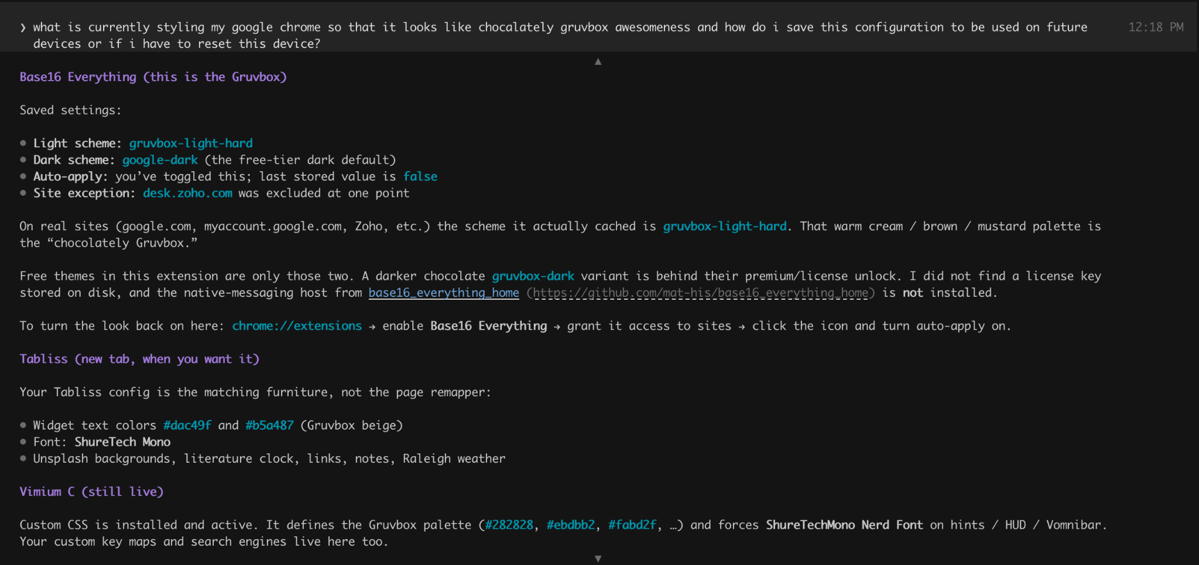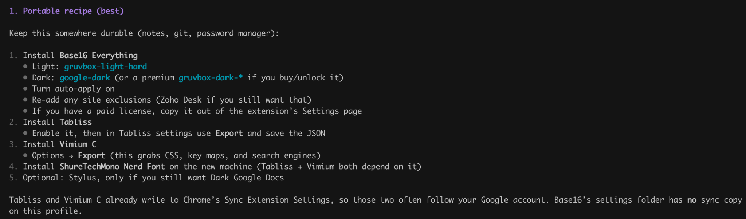
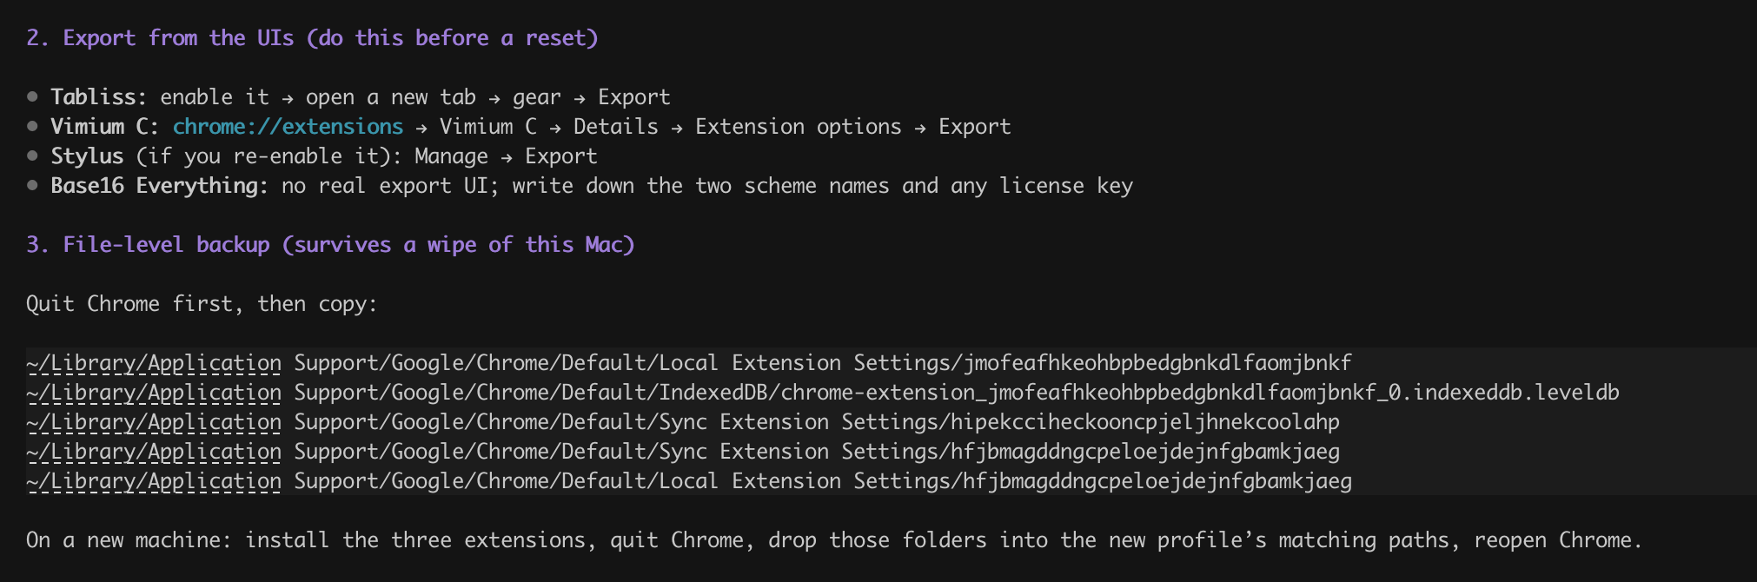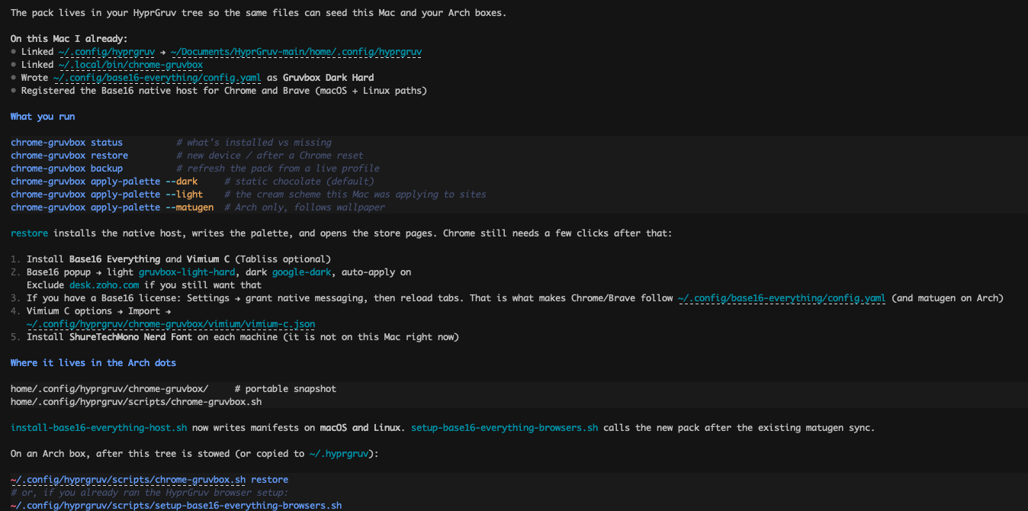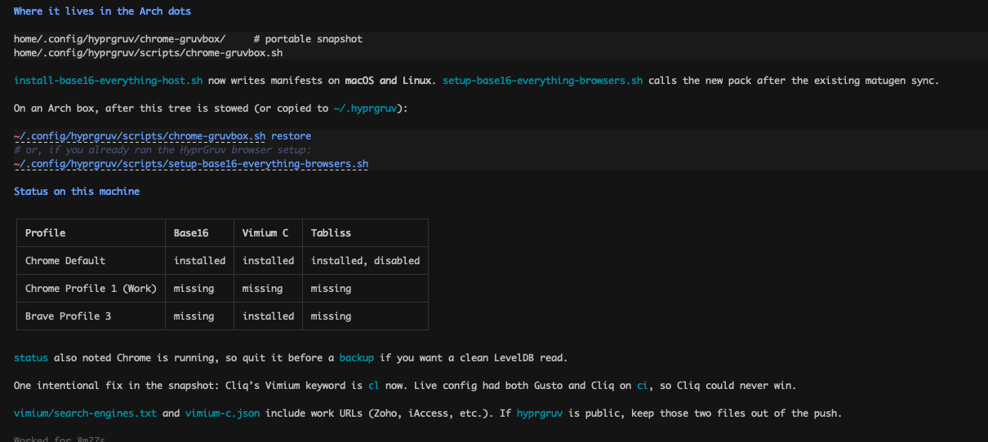

- Getting an error from the image; need to resolve
- “Only choice after theme - Esc = theme default - theme standard apply
The following warnings were detected when starting rofi:
Validating the theme failed: the variable ‘selected-normal-background ' in ‘element selected {background-color: var(selected-normal-background);}’ failed to resolve.
Do not need to have names of the colors,s as they may not be the same for palettes; need to just have colors from the screenshots saved in a file

